PROJECT REPORT  
*DANA –4820*

HEART DISEASE PREDICTION

*Team:*

*SATYAM VATTS(100368408)   
AVNEET KAUR(100368395)  
KIRAN VIKRAM ANGA(100368125)   
RADHIKA MAINI(100340257)*

SUBMITTED TO: AZADEH ALIMADAD

# **Data Overview**

The analysis has been done on the Heart Dataset which consists of **303** observations, **13** predictors and **1** binary Response variable indicating if the person has heart disease or not. The dataset is taken from UCI Machine Learning Repository which originally constituted 76 attributes. However, all the published experiments refer to using subset of only 14 variables, so we have also used the same for our analysis. Source of the database is V.A. Medical Centre, Long Beach and Cleveland Clinic Foundation. The variables are described below:

|  |  |  |  |
| --- | --- | --- | --- |
|  | **Variable** | **Datatype** | **Description** |
| 1 | Age | Quantitative | age of the patient [years] |
| 2 | Sex | Categorical | sex of the patient |
| 3 | cp | Categorical | chest pain type [0: Typical Angina, 1: Atypical Angina, 2: Non-Anginal Pain, 3: Asymptomatic] |
| 4 | tresbps | Quantitative | resting blood pressure [mm Hg] |
| 5 | chol | Quantitative | serum cholesterol [mm/dl] |
| 6 | fbs | Categorical | fasting blood sugar [1: if fbs > 120 mg/dl, 0: otherwise] |
| 7 | restecg | Categorical | resting electrocardiogram results [0: Normal, 1: having ST-T wave abnormality (T wave inversions and/or ST elevation or depression of > 0.05 mV), 2: showing probable or definite left ventricular hypertrophy by Estes' criteria] |
| 8 | Thalach | Quantitative | maximum heart rate achieved |
| 9 | Exang | Categorical | exercise-induced angina [1: Yes, 0: No] |
| 10 | Oldpeak | Quantitative | ST depression induced by exercise relative to rest |
| 11 | Ca | Categorical | Number of major vessels [0 to 3] colored by fluoroscopy |
| 12 | Thal | Categorical | defect type [1: Normal, 2: Fixed Defect, 3: Reversible defect |
| 13 | Slope | Categorical | the slope of the peak exercise ST segment [0: up sloping, 1: flat, 2: down sloping] |
| 14 | target | Categorical | output class [1: heart disease, 0: Normal] |

# **Data Pre-processing and Exploratory Data Analysis**

**Summary statistics** of all the variables is shown below:

Observations:

* ca : The value of 4 is invalid as data description says that the value for ca lies between 0 to 3.
* thal : 0 is an invalid value as it can either be 1 that is Normal, 1 Fixed defect, 2 Reversible Defect.
* There were no missing values
* 1 duplicate row as there are 302 distinct rows instead of 303

Thus, rows consisting invalid values of ca, thal and the duplicate row were dropped from the dataset. The cleaned and final dataset now had **296** observations and **14** variables.

**Distribution** of few variables is illustrated below:

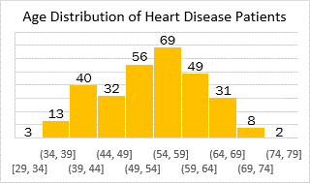

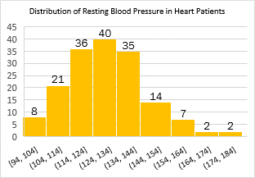

**Observations:**

A majority of Heart Patients

* Are in the age bracket of **50 to 60** years
* Are male
* Experience Non-Anginal Chest Pain
* Showed resting blood pressure between 114 to 144
* Showed ST-T wave abnormality in resting electrocardiography results

# **Research Objective**

Cardiovascular Disease is the leading cause of deaths globally. Every year 17.9 million people die due to the cardiovascular diseases. Heart attack which is also known as myocardial infraction happens when the muscles in the heart  don't  get enough blood . The more the time passes to restore the blood flow , the more damage it can cause to the heart muscle . It requires early detection and management wherein machine learning model could be of great use. So ,the objective of the research is to **detect symptoms and clinical tests can be used to diagnose heart disease at an early stage**. We’ll perform Logistic Regression as we are trying to predict the presence or absence of heart disease in patients – a binomial variable.

# **Inferential Analysis**

## *T – Test for Numerical Variables*

We are trying to find if there are any differences between the groups of patients based on presence or absence of heart disease. It helps us to identify the variables that show significant difference between the two groups based on mean value – for patients with and without heart disease.

*H0 : Mean of the two groups are equal*

*Ha : Mean of the two groups are unequal*

Before performing T test, we looked whether the variances within groups were equal or not to perform appropriate T-Test:

**Observations**:

* Variances are equal for tresbps and chol
* Variances are unequal for thalach, oldpeak and age

**Observations** :

* Chol : p-value = 0.18 which is greater than 0.05. Therefore, we can say there is no difference in the means of variable chol within the groups of people with and without heart disease. Hence, chol variable is insignificant for further analysis.
* For rest of the variables, p -value are less than 0.05. Thus, they are considered significant.

## *Chi-square Test for categorical variables*

The Chi-Square Test was conducted to find whether the groups based on presence or absence of the heart diseases are independent or interdependent of various factors present in dataset that are categorical in nature . It will help us to identify variables with any association with the response variable.

*H0 There is no association between the variables, i.e., they are independent*

*Ha :The variables are associated i.e. , they are not independent*

Observations:

* The variable **fbs** has a p-value of 1. This indicates that we must accept the null hypothesis and conclude that there is no significant association between the Fasting Blood Sugar Levels and person suffering for heart disease or not. Thus, it is not a significant predictor and is not considered for further analysis.
* All other categorical factors show association with the response. Thus, are important for making predictions of response.

# **Correlation Analysis**

Correlation analysis is performed to address the issue of multicollinearity between the predictors. Multicollinearity causes unstable prediction model. Thus, we need to check and eliminate any such issue.

In order to verify whether the numerical variables are at all related, we have developed a correlation plot with correlation coefficients as shown below:

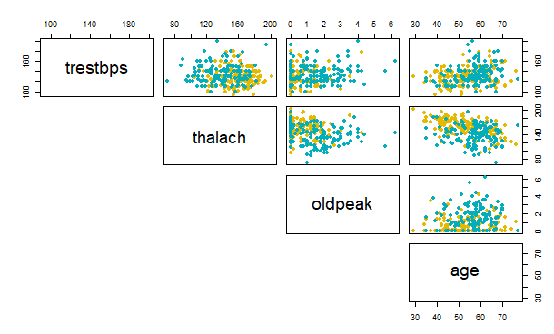 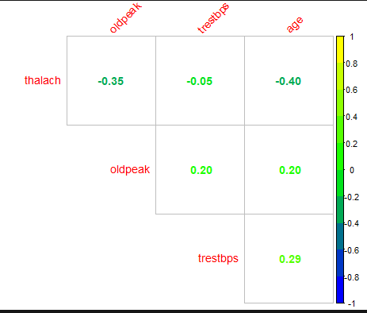

Observations:

* The correlation coefficients of all the combinations is too less to be considered significant. The highest correlation coefficient is -0.4 which is still less than -0.5.
* The scatterplots verify the notion of uncorrelated predictors as there is no linear pattern for any of the variable combination.

Thus, we conclude that our dataset doesn’t have multicollinearity issue.

# **Interaction Analysis**

The presence of interaction between predictors plays an important role in building prediction model. It is caused when the effect of a variable is different for different values of another variable. In this analysis, we analysed interaction between all the combination of predictors. Based on our results, three interactions were found between predictors as given below:

* ca and sex

* slope & sex

* thal & sex

Observations:

* The predicted probabilities are plotted against the values of categorical variables. The intersection between the lines indicated presence of interaction.
* ca:sex, slope:sex & thal:sex are the three interaction terms identified.

As the interaction between thal and sex is high(cuts the plot twice), we have taken this interaction term for the rest of the analysis & to perform comparison between models.

# **Regression Analysis**

Ultimately, the selected set of predictors are taken to develop a Logistic Regression Model. This model aims at predicting the presence or absence of heart disease in patents based on their health status determined by different factors.

## *Data Splitting:*

Before proceeding with model development, the dataset is split into two sets:

* Training Set: 207 Observations
* Test Set: 89 Observations

This split of 7:3 ratio is needed to validate the accuracy of the model.

## *Variable Selection: Stepwise regression based on AIC*

Although, the inferential analysis helped us remove some of the insignificant predictors, we have performed Stepwise Logistic regression using **stepAIC** method in R. This method helped us generate a model with optimal set of predictors selected based on forward selection as well as backward elimination.

We performed the analysis for with and without the preselected interaction term, but the function resulted in the same regression model, one without any interaction term. PFB the results of the analysis:

***Without Interaction With Interaction: Sex:Thal***

**Observations:**

* It can be observed that both the calls to stepAIC function i.e., with or without interaction result in same final model with 6 predictors namely sex, cp, restecg, slope, ca & thal.
* The final model AIC is 135.8 with a Null Deviance of 285.6.

Thus, it can be seen that the interaction term is not significant for the prediction model. To appreciate this result, we will consider a model with interaction term for further analysis to compare it with the model without any interaction term.

**Without Interaction Model :** target ~ sex + cp + slope + ca + thal

**With Interaction model :** target ~ sex + cp + slope + ca + thal + sex:thal

# **Model Comparison**

The prediction models are compared to determine the significance of interaction term using two significance testing methods namely Wald Test and Log-Likelihood Ratio Test. The results of these tests are summarised below:

Model without Interaction Model with Interaction

* ***Wald Test:*** The test was performed to check whether the interaction term is significant for the prediction model or not.

H0 : The reduced model is appropriate | Coefficient of Interaction term is 0  
Ha: Full model is appropriate | Coefficient of Interaction term is not 0

It can be observed from the result that p-value of the test is greater than 0.05, thus, we fail to reject the null hypothesis and conclude that interaction term is not significant i.e., the reduced model is appropriate.

* ***Log-Likelihood Ratio Test:*** The test was performed to verify the significance of interaction term i.e., to compare the model with & without interaction term. It is performed using the Anova function in R.

H0: Reduced model is appropriate  
Ha: Full model is appropriate

It can be observed that p-value of chi-sq statistics obtained using the difference of residual deviances of two models is greater than 0.05 indicating that the model without interaction term is more appropriate i.e., the interaction term is not significant predictor to be considered.

The model comparison performed using Wald and Likelihood Ratio test both indicated that the interaction term is not significant for the prediction model.

# **Prediction Accuracy**

The accuracy of model is an important metric to verify how accurate the predictions are on a testing dataset given that the model is trained on a training dataset. The accuracy is determined using two metrics, a classification report specifying confusion matrix and the other using ROC Curve. We have performed the analysis for both the without and with interaction terms model to compare. The threshold value of predicted probabilities is taken as the average of response variable in the whole data set which has a value of 0.54. Thus, probabilities more than 0.54 are considered as 1 and rest as 0.

## *Classification Report*

The classification report is a detailed description of predictions made on test dataset and how the model performs on a new set of data.

**Model without Interaction:**

Observations:

* The model has an overall accuracy of 74%.
* Out of 89 test data observations, 23 were misclassified.
* The Sensitivity of detecting the positive cases i.e., people with heart disease is 72.9%
* The Specificity of detecting negative cases is 75.6%

Thus, the model is acceptable as it performs moderately good. The accuracy can be further increase if the number of training observations are more making it more robust.

**Model with Interaction:**

Observations:

* The model has an overall accuracy of 78.6%.
* Out of 89 test data observations, 19 were misclassified.
* The Sensitivity of detecting the positive cases i.e., people with heart disease is 81.2%
* The Specificity of detecting negative cases is 75.6%

It can be observed that the accuracy of model with interaction is more as compared to without interaction. This result is contradictory to our earlier analysis where we discovered and verified that interaction term is not significant. However, since the dataset is small, presence of more parameters in the model allows it fit more rigidly to the test dataset. Also, the training set is small, the observations from accuracy result are contradictory.

The results signifying the insignificance of interaction term can be better appreciated if we have large dataset and we can perform cross validation for different sample test dataset finally averaging out the accuracy.

## *ROC Curves:*

The ROC curves provide a more powerful metric to determine the accuracy of the model as they take into the account all possible values of threshold values and plot a graph between the sensitivity and specificity of the predictive model.

The plot has been made for both with and without interaction models for comparison.

***Model without Interaction Model with Interaction***

Observations:

* The Area Under Curve signifying the accuracy of model is 0.7426 for model without interaction.
* The model with interaction has a higher AUC of 0.7842.

It can be observed that here again the predictive power of model with interaction is more than without interaction. As mentioned earlier, this is due to limited data available.

# **Fitness Analysis**

Lastly, we analysed the fitness of model using Hosmer-Lemeshow Test to verify how these models compare to the saturated model and determine if they are a good fit or lacks appropriate level of fit to be considered fruitful for predictions.

H0 : The reduced model is fitted  
Ha : The saturated model is fitted

***Model without Interaction Model with Interaction***

The p-value of test for the models is greater than 0.05, therefore, we fail to reject the null hypothesis. The results specify that both the models are a good fit and thus can be considered for prediction of patients with or without heat disease.

# **Conclusion**

This report detailed the analysis on heart disease dataset for 303 patients categorizing as a heart disease patient or not based on various health parameters and test results. We treated the dataset to remove invalid values from ca & thal and removed duplicated data. Inferential analysis was performed to determine the variables that distinguish the two groups of people and thus will be significant using T-test and Chi-Square tests. We found that fbs(fasting blood sugar) and chol(cholesterol) are not significant and thus removed them from dataset. We performed correlation analysis to check multicollinearity and as it was found that there is no collinearity in the dataset. In order to check whether the predictors interact to have effect on response, we performed interaction analysis and discovered 3 pairs of variables showing interaction. We chose interaction of sex and thal for further analysis as it showed high interaction based on interaction plots. We then performed the regression analysis to develop our prediction model for both with interaction and without interaction. Later ,we analysed the accuracy of these models using classification report & ROC curves. Both analyses showed model with interaction performed better although this result is due to limited data availability and may change in presence of large data. Since, the interaction term was insignificant in all the tests, the accuracy metrics are contradictory and hence require further analysis using more data which is out of scope of this research. We also determined the goodness of fit for both models and got that both are a good fit.

Such a predictive model can be used by hospitals to better identify the status of a patient and can help in early diagnosis of heart disease. This can save lives by starting medication and treatment at an early stage of disease and thus increasing the chances of recovery.

# **APPENDIX**

## *Sources*

UCI Machine Learning Repository : <https://archive.ics.uci.edu/ml/datasets/heart+disease>

Kaggle Dataset: <https://www.kaggle.com/ronitf/heart-disease-uci>

## *R-Code*

Attached for reference